Selection statement if..elseif..else

Workshop #4

Flutter Developer Bootcamp

# **Purpose**

This workshop demonstrates the conditional logic using an if-else if-else structure based on the value of the variable alphabet.

**Problem**

In the given workshop demonstrates the program checks the value of the variable alphabet, which is initially set to 's'. It uses conditional statements (if, else if, else) to print different messages based on whether alphabet equals 'q', 'r', or neither. Since alphabet is 's', the program executes the else block, You need to create else block for printing 'alphabet is not q or r' to the console. This demonstrates basic conditional logic in Dart, essential for making decisions in programming tasks.

**How to Solve**

1. Checkout the workshop from Git Repo:

git clone -b <user-branch> <repo-URL>

1. Open the root folder inside VS Code
2. Open the root folder in terminal
3. Run the command dart run filename.dart
4. Variable Declaration: Initializes alphabet as 's'.
5. Conditional Statements:

* Checks if alphabet is 'q' and prints 'alphabet is q' if true.
* Checks else if alphabet is 'r' and prints 'alphabet is r' if true.
* Prints 'alphabet is not q or r' if neither condition is met.

1. Go To File: <specific-file--method> à <method-name>, implement your logic.

**You will Achieve**

When you complete this workshop you will learn the following:

Methods and Functions Included**:**

* **main Function:**
* void main(List<String> args)
* Entry point of the Dart program where execution begins. Accepts command-line arguments (args) which are unused in this example.
* **print Function:**
* print('alphabet is q');, print('alphabet is r');, print('alphabet is not q or r');
* Outputs messages to the console based on conditional evaluations (if, else if, else).

# **Screenshots**

## **Before implementation (without else)**

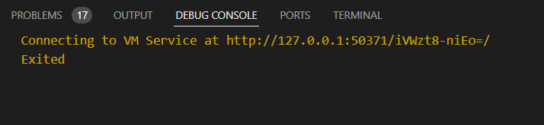

## **After implementation (with else)**

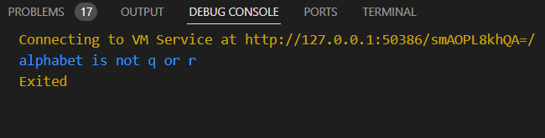

# **How to submit your workshop**

Push your project back to the same git branch using command:

<command name>

# **Happy Coding!**